PRIMARY THREE
R.E
LESSON NOTES
FOR
TERM ONE (2015)

COMPILED BY;
- ALEX MUTOTO
- ROBERTSON WANZU
- MONICAH AYIYA
- ISAAC BUYUNGO
- GODFREY KATENDE

WEEK 2: Lesson 1
Spellings
- Jesus
- Christmas
- Bethlehem
- Nazareth
- Jordan

THEME 1: CHRISTIANS GROW IN JESUS

TRADITIONS/ CUSTOMS

1. What are customs?
Customs are traditional and religious practices in a society.

2. Examples of traditional customs in our society
- Greeting.
- Naming twins.
- Bowing down before kings.
- Paying bride price.
- Having last funeral rites.
- Dressing
- Welcoming visitors at home.

3. People who teach us customs include:
- Parents
- Teachers
- Pastors
- Elders
- Grand parents

Activity
- What term is used to mean the traditional practices of a society?
- Name two traditions among the Baganda
- Draw and colour yourself performing any one custom at home.

WEEK 2: Lesson 2
Spellings
- custom
- traditional
- religious
- society
- greeting

Importance of customs in our society

(a)Greeting;
- Creates friendship
- Sign of respect
- Makes people feel happy.

(b) Paying bride price/wealth;
- Sign of thanks you to the girl’s family.
- Sign of responsibility.
- To stabilize marriage.

(c) Naming children;
- For identification
- Creates unity among clan members.

(d) Welcoming visitors;
  - To show respect.
  - To create friendship.

(e) Mourning for the dead;
- Way of showing sorrow.
- Sign of love for the dead.

Activity
- Name any two customs at school.
- Why we greet one another?
- What do you do when you receive a visitor?

WEEK 2: Lesson 3
Spellings
- friend
- identification
- marriage
- respect
- sorrow

Customs in the Christian family
1. Christian customs help to unite us in God’s family

2. Examples of Christian customs;
- Attending church services.
- Baptism (John 1:29-34)
- Confirmation
- Holy marriage
- Fasting during lent period.
- Praying for the sick.
- Praying before a meal.
- Paying tithes and offertories.

3. What is the importance of baptism in Christian family?
- To wash away the original sin.
- To bring us into God’s family.

Activity
- Name any two Christian customs.
- Which custom helps a man and woman to be husband and wife?
- Why do we pay tithes and offertories?
- Draw, name and colour any one Christian custom.

WEEK 3: Lesson 1
Spellings
- family
- baptism
- marriage
- Christian
- fasting

Other customs we meet

1. Each society has its own customs e.g.
The Baganda bow down before their Kabaka.

2. Why should we respect other people’s customs?
- To fit in every society.
- To live happily with other people.
- To learn the behavior of other people.

TOPICAL TEST

- What are customs?
- Give two examples of customs in your society
- Why do Baganda women and girls kneel while greeting?
- Mention any two Christian customs?
- Of what importance is baptism to a Christian?
- In which place did Jesus attend the wedding ceremony?

WEEK 3: Lesson 2
Spellings
- wedding
- baptism
- traditional
- greeting
- custom

LEADERSHIP
Read;
Eph 4:11-13
Mark9:33-35

1. What is leadership?
Leadership is a position of guiding or managing others

2. Who is a leader?
-A person given a responsibility of guiding others.
-A leader is a person who guides or manages others.

3. Examples of leaders include:

- president
- A head teacher
- Classteachers
- Head prefect
- Class prefects
- Pastors
- Bishops
- Kings

4. Qualities of a good leader
1 Tim3:1-7
- Should lead by example.
- Should be a good listener.
- Should make good decisions.
- Should be kind
- Should not be God-fearing.
- Should be patient.

Activity
1. Who is a leader?
2. Give any two characteristics of a good leader.
3. Who heads a church?

WEEK 3: Lesson 3
Spellings
- leader
- leadership
- God-fearing
- prefects
- president

LEVELS OF LEADERSHIP IN OUR SOCIETY
- At different levels and places, we have different leaders

These include:
(a)At family level;
- Father
- Mother

(b)At school level;
- Head teacher
- Deputy head teachers
- Heads of department
- Class teachers
- Prefects etc

(c)At church level;
Read;
Eph 4:11-13
- Bishops
- priests
- Reverends
- Pastors
- Deacons and ushers

(d)At community level;
- L C 3 Chairperson at the sub-county level
- L C 2 Chairperson at the parish level
- L C 1 chairperson at the village level

(e)At clan level
- Clan head
- Lineage head
- Family heads

Activity
- Mention any two leaders at school.
- Who heads a church?

WEEK4: Lesson 1
Spellings
- Pastor
- Reverend
- Bishop
- Priest
- Chairperson

1. Examples of leaders in the Old Testament

- Abraham
- Moses
- Joshua
- Samuel
- Kings like David, Solomon etc

A). ABRAHAM AS A LEADER
Gen 12:1-5
Gen22
- Abraham’s wife was Sarah.
- They lived in a country called Haran (Ur).
- God told Abraham to leave his homeland and go to another land.
- Canaan was the new land God promised Abraham.
- Isaac was the son God gave to Abraham and Sarah.
- God asked Abraham to sacrifice his only son, Isaac.
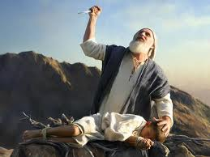

- When Abraham obeyed, God made him the grandfather of all nations.
- N.B Ishmael is the son whom Abraham had from his maid, Hagar.

Activity
- Who was the wife of Abraham?
- Which land was promised to Isaac?
- Why did God ask Abraham to sacrifice his son?

WEEK4: Lesson 2
Spellings
- Abraham
- Canaan
- Isaac
- Sarah
- Sacrifice

b).MOSES AS A LEADER OF GOD
Exodus 3
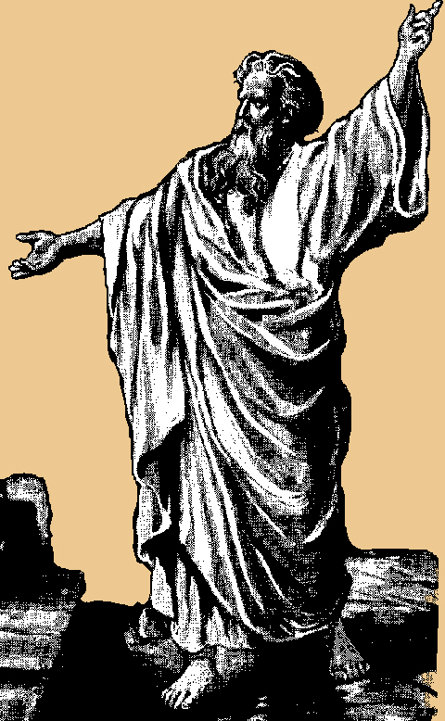
Moses
- Moses was a shepherd before he became a leader.
- God first appeared to Moses on Mt Sinai (Horeb) in form of a burning bush.
- Moses was told lead the Israelites from Egypt to the Promised Land.
- He led the Israelites out of Egypt across the Red sea.
- Moses died on the way because he disobeyed God.
- He was buried on Mt Nebo.

Activity
- Who led the Israelites out of Egypt?
- Name the water body which was crossed by the Israelites from Egypt.
- In which form did God first appear to Moses?
- Why didn’t Moses reach the Promised Land?

WEEK 4: Lesson 3
Spellings
- Moses
- Mt Sinai
- Egypt
- Red sea
- shepherd

JOSHUA AS A LEADER OF GOD
Joshua1:1-3
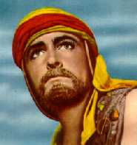
- Joshua succeeded Moses.
- He led the Israelites across River Jordan to the Promised Land.
- The Promised Land was called Canaan.
4. Qualities of leaders in the Old Testament
- They were God-fearing.
- They were obedient
- They were faithful.
- They wear brave.

Activity
- Who lead the Israelites to the Promised Land?
- Name the river which was crossed by the Israelites to the Promised Land.
3. What was the name of the Promised Land?
4. Give any two qualities of leaders in the Bible.

WEEK 5: Lesson 1
Spellings
- Canaan
- Joshua
- Jordan
- Israel
- Testament

JESUS AS A LEADER
Read;
Mark10:13-15
John2:13-16
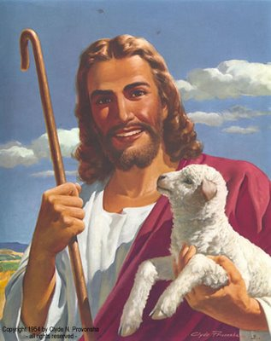

1. How was Jesus Christ a good leader?
- Jesus was a servant of all people.
- Jesus treated all people fairly.
- He was humble.
- He was loving and caring.
- He was obedient to the law.
- He was God fearing.

Activity
- Give two ways in which Jesus was a good leader.
- What lesson do we learn from Jesus?
- Mention any two qualities of a bad leader.
- Draw and show Jesus with the little children

WEEK 5: Lesson 2
Spellings
- Jesus
- humble
- obedient
- honest
- servant

MESSENGERS OF GOD

How God speak to us
Isaiah6:1-10
1Sam13:1-21
1. Mention the ways how God speaks to us

- Through reading the Bible
- Using prophets, priests, pastors etc
- Through dreams
- Through visions

2. Who is a prophet?
A prophet is a messenger of God.

3. Examples of prophets in the Bible

- John the Baptist
- Isaiah
- Jeremiah
- Elijah
- Noah
- Joel
- Moses
- Amos
- Micah
- Ezekiel

4. Qualities of people chooses to be his messengers
- They are faithful
- They are trustworthy
- They are obedient
- They are not proud
- They humble

Activity
- List any two way how God can speaks to us.
- Who is a prophet?
- Mention any three prophets in the Bible.

WEEK 5: Lesson 3
Spellings
- prophet
- message
- messenger
- Isaiah
- Jeremiah

NOAH AS A MESSENGER
Gen 6:1-8
- God told Noah to build the big boat called the Ark.
- The Ark saved Noah, his family and other creatures from the flood.
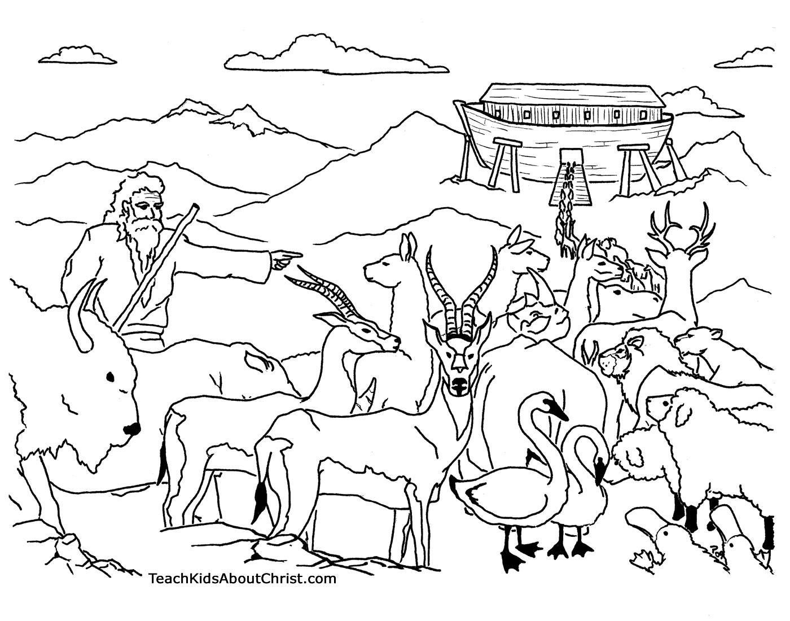

- It rained for 40 days and nights but it took 150 days for the floods to dry up.
- Noah sent a dove to check whether the floods had dried.
- The names of Noah’s sons were:
  - Shem
  - Ham
  - Japheth
- Only 8 people were saved from the floods.
- Noah’s ark rested on Mountain Ararat.
Activity
- Who built the ark?
- For how long was the flood in Noah’s time?
- On which mountain did the Ark rest?

WEEK 6: Lesson 1
Spellings
- floods
- Ark
- Ararat
- creatures
- messenger

Angels as God’s messengers
Read:
Luke1:26-38
1. Who are angels?
Angels are heavenly messengers of God.

2. Angel Gabriel brought the message to Mary about the birth of Jesus Christ.
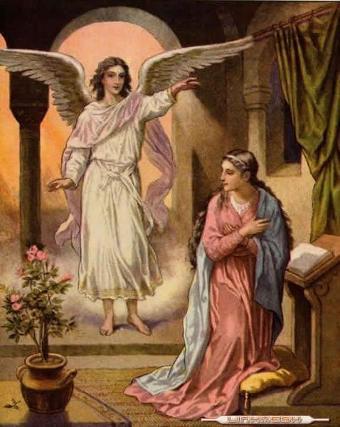

Activity
- How is an angel different from a prophet?
- Which angel brought the good news to Mary?
- What do we learn from virgin Mary?

WEEK 6: Lesson 2
Spellings
- angel
- message
- heaven
- Gabriel
- Mary

Messages about Jesus from God’s messengers

(a)Prophet Isaiah (Isa 53)
  - He talked about the coming of Jesus.
  - He said that Jesus would suffer on behalf of Christian.
  - That Jesus would be beaten, wounded and killed.

(b) Prophet Micah (Micah 5:2)
He said that Jesus would be born in the town called Bethlehem.

(c) Prophet Zechariah (Zech 9:9)
- He also said that Jesus would go to Jerusalem on a donkey. ( a colt)

(d) John the Baptist
- He was the last prophet in the Bible
- He prepare for the coming of Jesus Christ.
- He baptized Jesus at River Jordan.

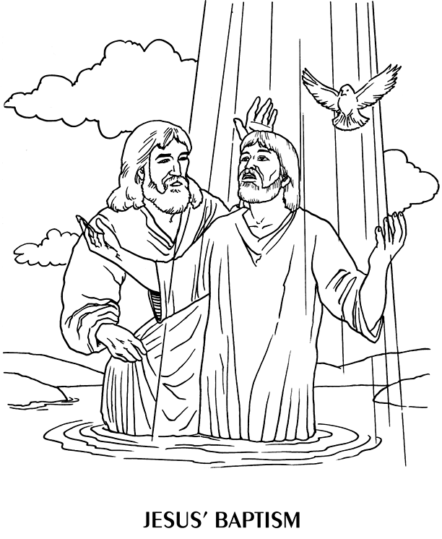

Activity
- Which prophet said that Jesus would beat and killed?
- In which town was Jesus born?
- Who baptized Jesus?
- Name the river where Jesus was baptized.

WEEK: 6 Lesson 3
Spellings
- Jerusalem
- Nazareth
- Saviour
- Baptist
- baptize

SORROW AND JOY IN LIFE

LENT
Read;
Matt6:16-18
1. What is lent?
Lent is the fasting period for Christians.
2. Lent period lasts for forty (40) days.
3. Christians begin their lent on Ash Wednesday.
4. Reasons why Christians fast
- To repent their sins.
- To renew their faith.
- To get power over sin and satan.
- To get blessings
5. What should a Christian do during lent?
- Repenting his/her sins
- Forgiving others
- Praying to God
- Reading the Bible

Activity
- What do we call the fasting period for Christians?
- When do Christians begin fasting?
3. Mention any three things a Christian should not do during lent.
4. Why do Christians fast?

WEEK 7: Lesson 1
Spellings
- fasting
- repenting
- forgiving
- praying
- blessing

JESUS’ STAY IN THE WILDERNESS
Read;
Luke 4:1-12
1. Jesus was in the wilderness for 40 days and nights.
2. He was fasting and praying.
3. He was tempted by devil or Satan.
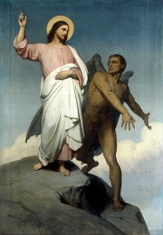

Temptations given to Jesus
- To turn the rock (stone) into bread.
- To bow down and worship the devil.
- To fall down from the highest point of the temple.

Activity
- For how long was Jesus in the wilderness?
- Who tempted Jesus?
- Mention any one temptation given to Jesus.
- What should we do when we are tempted?

WEEK 7 :Lesson 2
Spellings
- devil
- temptation
- worship
- temple
- wilderness

THE HOLY WEEK
Read;
Mark 14 & 15
1. What was known as the Holy week?
It was the week in which Jesus died for our sins.

2. What happened during the Holy Week?

a)Palm Sunday (John 12:9-19)
Jesus entered Jerusalem riding a donkey.
b)Holy Thursday
Jesus had the last supper with his apostles.
c) Good Friday
Jesus was crucified/nailed on the cross.
d) Easter Sunday
Jesus resurrected or rose from the dead.

Activity
Match the following correctly.
A B
Palm Sunday -Jesus rose from the dead.
Good Friday -Jesus entered Jerusalem on a donkey.
Easter Sunday -Jesus had his last supper.
Holy Thursday -Jesus was crucified.

WEEK:7 Lesson 3
Spellings
- apostle
- disciple
- crucified
- resurrected
- supper
THE LAST SUPPER
Read;
Luke 22:14-23
1. What was the Last Supper?
This was the last meal Jesus had with his apostles.
2. Jesus had the last supper on the Holy Thursday.
3. They used bread and wine during the Last Supper.
4. The bread represented the body of Jesus Christ.
5. The wine represented the blood of Jesus Christ.
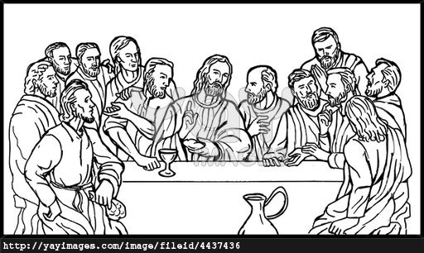
- Christians today celebrate the Lord’s Supper through the Holy Communion or Holy Eucharist.

Activity
On which did Jesus have his Last supper?
Name the two things that were used during the Last supper?
What do the following represent during Holy Communion?
- the bread
- the wine

WEEK: 8 Lesson 1
Spellings
- wine
- bread
- celebrate
- communion
- represent
JESUS’ CRUCIFIXION AND DEATH
Read;
Matthew 27; 32-53
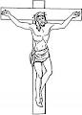
Luke 22:14-9-23
  - Judas Iscariot betrayed Jesus while Simon Peter denied him 3 times.
  - Pontius Pilate is the Roman governor who sentenced Jesus.
3. Jesus was crucified on Good Friday.
4. He was crucified on the cross at a place called Golgotha.

5. What happened at Jesus’ death on the cross?
- There was total darkness (an eclipse) from noon.
- The temple curtain tore into two pieces.
- There was an earth quake.
- The graves opened.
- The holy people rose up.

6. Joseph of Arimathea buried the body of Jesus.

Activity
- On which day was Jesus crucified?
- Name the apostle who betrayed Jesus Christ.
- Why is Joseph of Arimathea remembered in the Bible?
- Identify any one event which happened at Jesus’ death?

WEEK: 8 Lesson 2
Spellings
- Golgotha
- Simon Peter
- Pontius Pilate
- Judas Iscariot
- Arimathea

JESUS’ RESURRECTION
Read;
Luke 24:1-12
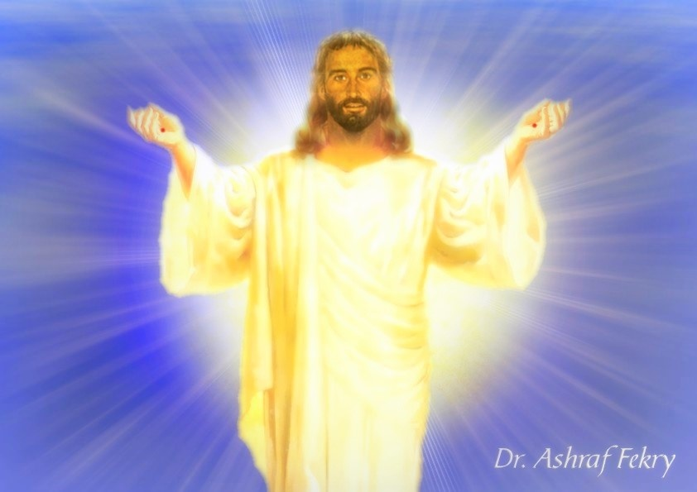

1. Jesus rose from the dead on Easter Sunday.
2. He re-appeared to Mary and the apostles.
3. Thomas doubted the resurrection of Jesus Christ.
4. Jesus went to heaven on Ascension Day.
5. Why Jesus’ death and resurrection is important to us?
- Our sins were forgiven.
- Christians got power over Satan, sin and death.
- Christians have hope for life after death (eternal life).
6. Matthias is the apostle who replaced Judas Iscariot.
Activity
- Why is Easter Sunday important to Christians?
- What showed that Jesus had resurrected?
- Name the apostle who doubted Jesus’ resurrection.
- On which day did Jesus return to heaven.

THE END

